RC522 Pins

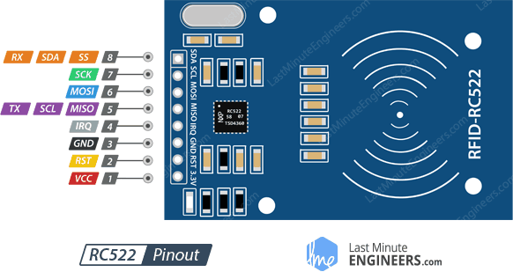

SS / SDA / Rx pin acts as a signal input when the SPI interface is enabled, as serial data when the I2C interface is enabled and as a serial data input when the UART interface is enabled. This pin is usually marked by encasing the pin in a square so that it can be used as a reference to identify other pins.

**(IN) D2**

SCK (Serial Clock) accepts the clock pulses provided by the SPI bus master i.e. Arduino. **(Synchronization between controller and Arduino) D5**

MISO / SCL / Tx pin acts as master-in-slave-out when SPI interface is enabled, as serial clock when I2C interface is enabled and as serial data output when the UART interface is enabled. **(OUT) D6**

IRQ is an interrupt pin that alerts the microcontroller when an RFID tag is in the vicinity. **(Interrupt) NONE**

GND is the ground pin and needs to be connected to the GND pin on the Arduino. **(ground) GND**

RST is an input for reset and power-down. When this pin goes low the module enters power-down mode. In which the oscillator is turned off and the input pins are disconnected from the outside world. Whereas the module is reset on the rising edge of the signal. **(Shut down, reset) RST D1**

VCC supplies power to the module. This can be anywhere from 2.5 to 3.3 volts. You can connect it to the 3.3V output from your Arduino. But remember that connecting it to the 5V pin will probably destroy your module! **(power) 3.3V**

ESP8266 Pin reference

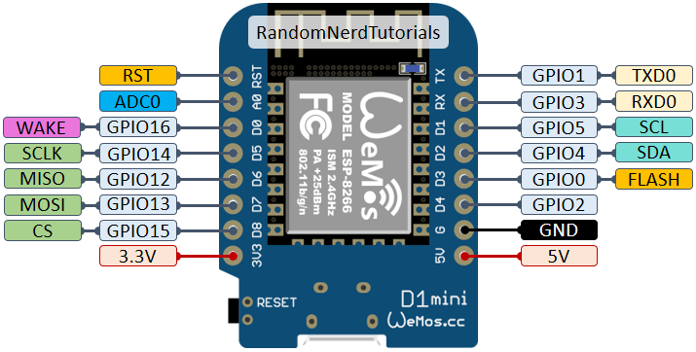

|  |  |  |
| --- | --- | --- |
| **Pin** | **Function** | **ESP-8266 Pin** |
| TX | TXD | TXD |
| RX | RXD | RXD |
| A0 | Analog input, max 3.3V input | A0 |
| D0 | IO | GPIO16 |
| D1 | IO, SCL | GPIO5 |
| D2 | IO, SDA | GPIO4 |
| D3 | IO, 10k Pull-up | GPIO0 |
| D4 | IO, 10k Pull-up, BUILTIN_LED | GPIO2 |
| D5 | IO, SCK | GPIO14 |
| D6 | IO, MISO | GPIO12 |
| D7 | IO, MOSI | GPIO13 |
| D8 | IO, 10k Pull-down, SS | GPIO15 |
| G | Ground | GND |
| 5V | 5V | - |
| 3V3 | 3.3V | 3.3V |
| RST | Reset | RST |